Git hub link: https://github.com/GayatriBhandari/Reproducibility-GB.git

Data description

Here, we will analyze mycotoxin data collected from wheat heads grown in the greenhouse inoculated with Fusarium graminearum (Fg) with or without fungal endophytes to protect against Fg. The experiment was performed by inoculating the heads with Fg (positive control), Fg + 1 of 3 endophytes (Fg + 40, Fg + 70, or Fg + 37), and the non-treated control (NTC). Therefore, the experiment was five treatments with 6-10 technical replicates and three experimental replicates. The authors quantified the parts per million (ppm) of mycotoxins Deoxynivalenol (DON) and the variant 15ADON from the wheat grain, and this is your primary response variable. In other words, we are interested in knowing if the fungal endophytes could reduce the concentration of DON on wheat heads. This was done across two wheat cultivars, a winter wheat variety, Ambassador, and a spring wheat variety, Wheaton. These data are published here:

- Noel, Z.A., Roze, L.V., Breunig, M., Trail, F. 2022. Endophytic fungi as promising biocontrol agent to protect wheat from Fusarium graminearum head blight. Plant Disease. https://doi.org/10.1094/PDIS-06-21-1253-RE
- The following github repository is associated with this paper: https://github.com/noelzach/EndophyteBiocontrol

- 5 pts. Explain the following concepts about ggplot
  - What three elements do you need to produce a ggplot?
    - Data – a data frame containing the variables to plot
    - Aesthetic mappings (aes())- defines how variables are mapped to visual properties (x,y,colr,shape,fill, etc.)
    - At least one geometric layer (geom_*)- specifies how data are displayed (points, bars, lines, boxplots, etc)

  - What is a geom?
Ans: A geom (geometric object) is the visual representation of data in a plot. It determines how the data appear.

Examples:
- geom_point() → scatterplot points
- geom_boxplot() → boxplots
- geom_bar() → bar charts
- geom_line() → lines

Each geom uses the mapped aesthetics to draw the visualization.

  - What is a facet?
Ans: A facet splits the data into subsets based on a categorical variable and creates separate panels for each subset.

Example:
facet_wrap(~Cultivar)

This produces one plot per cultivar.
Faceting allows comparison across groups while keeping the same structure and scales (or optionally free scales).

  - Explain the concept of layering.
Ans: Layering means building a plot by adding components using +.

Each layer can:
- Add a new geom
- Add statistical summaries
- Modify scales
- Adjust themes

Example:
ggplot(data, aes(x, y)) +
geom_boxplot() +
geom_point() +
theme_classic()

Here:
- First layer → boxplot
- Second layer → individual points
- Third layer → theme styling

Each layer is stacked in order.

  - Where do you add x and y variables and map different shapes, colors, and other attributes to the data?

Ans: You define them inside aes() (aesthetic mapping).

They can be placed:
- Globally inside ggplot() (applies to all layers)
- Inside a specific geom() (applies only to that layer)

Example (global mapping):
ggplot(data, aes(x = Treatment, y = DON, fill = Cultivar)) +
geom_boxplot()

Example (layer-specific mapping):
geom_point(aes(shape = Time_Point)

- 4 pts. Make a boxplot using ggplot with DON as the y variable, treatment as the x variable, and color mapped to the wheat cultivar. Change the y label to “DON (ppm)” and make the x label blank.

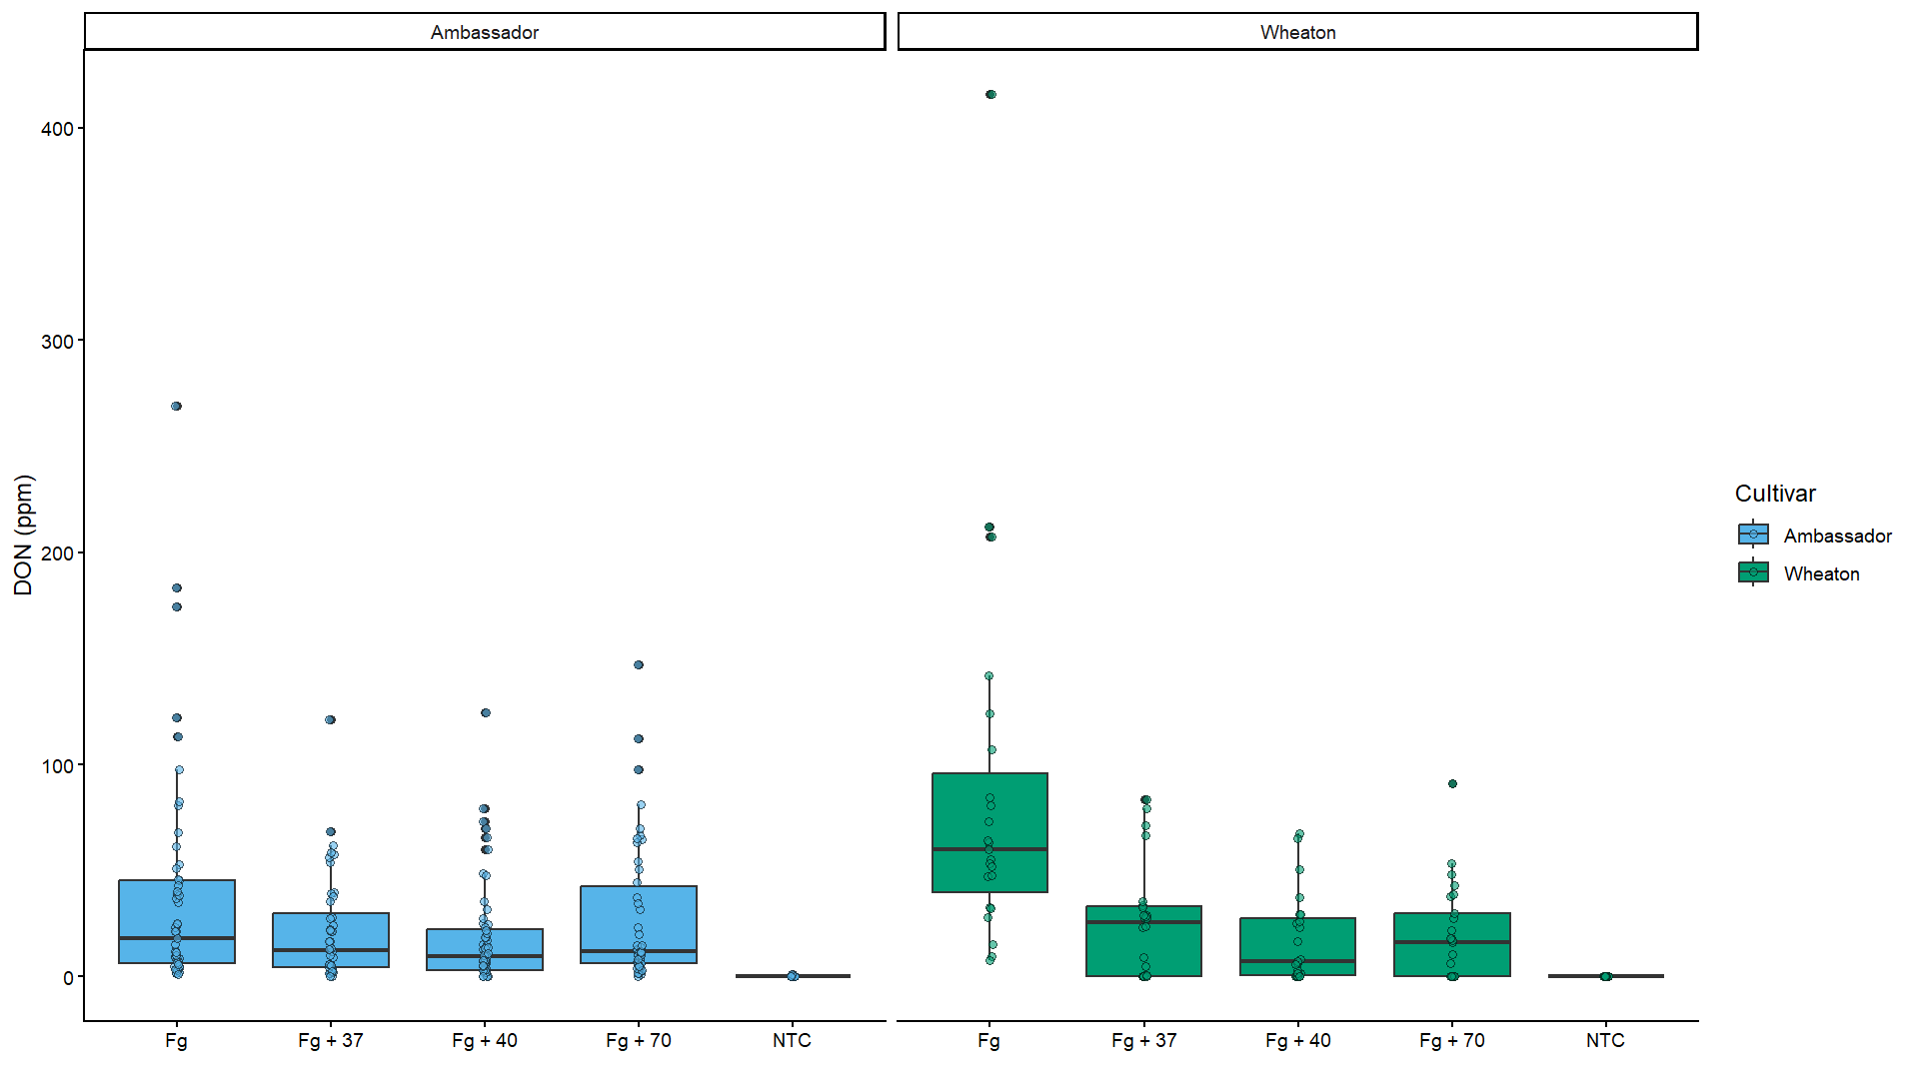

  - 4 pts. Now convert this data into a bar chart with standard-error error bars using the stat_summary() command. (hint: use position = dodge)

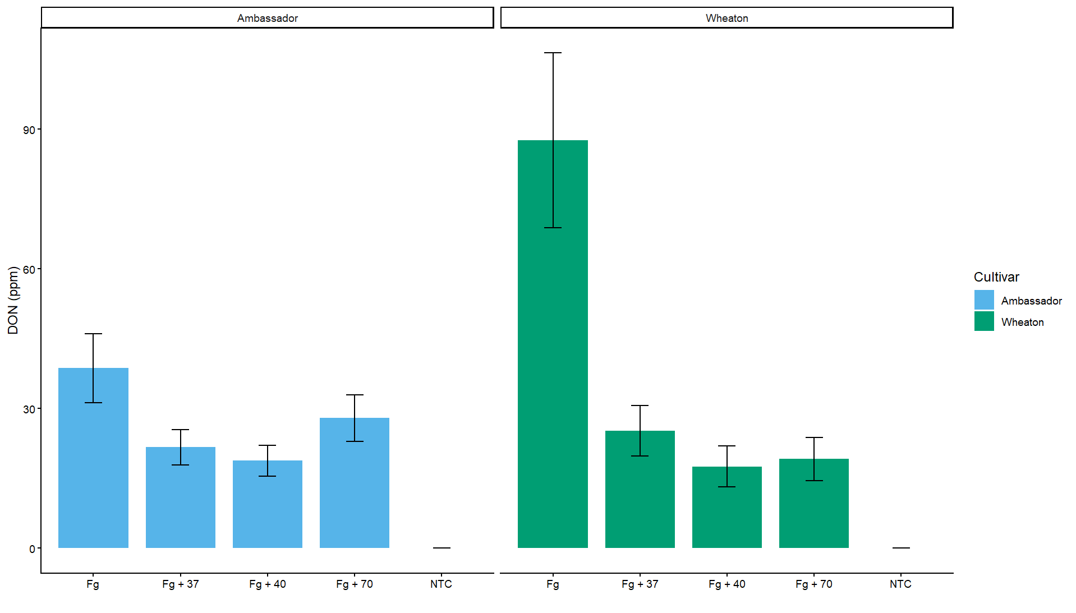

3 pts. Add points to the foreground of the boxplot and bar chart you made in questions 2 & 3 that show the distribution of points. Set the shape = 21 and the outline color black (hint: use jitter_dodge).

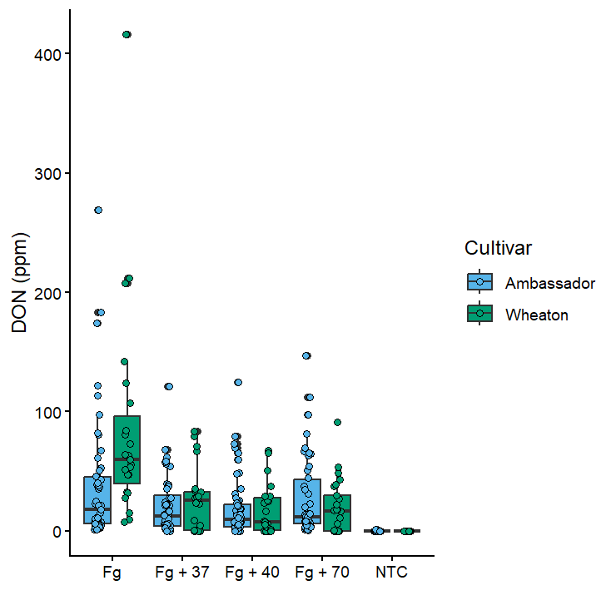

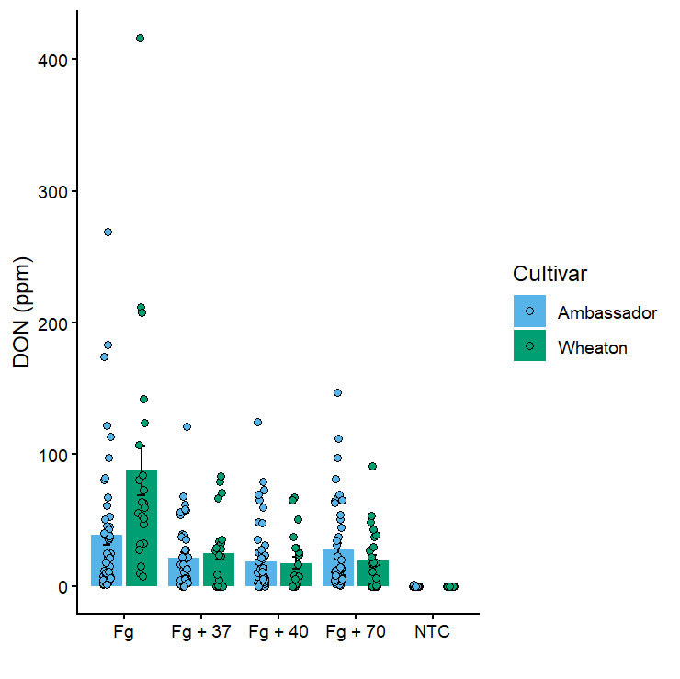

- 2 pts. Add a facet to the plots based on cultivar.

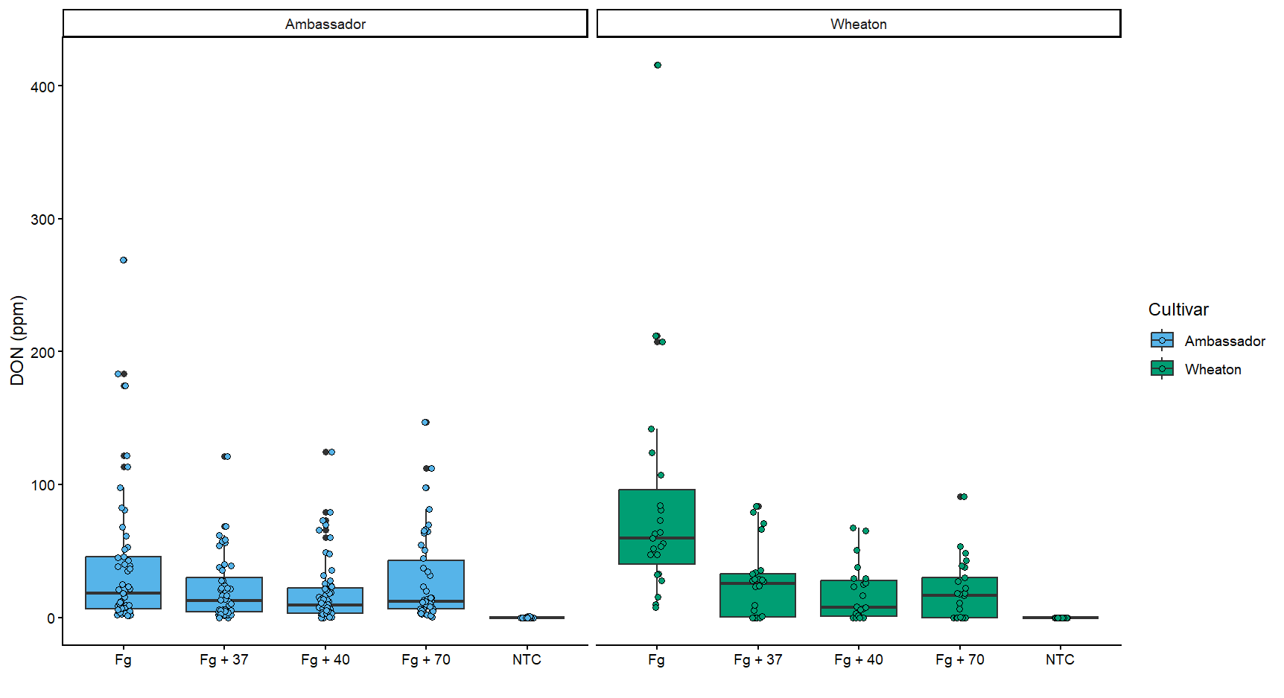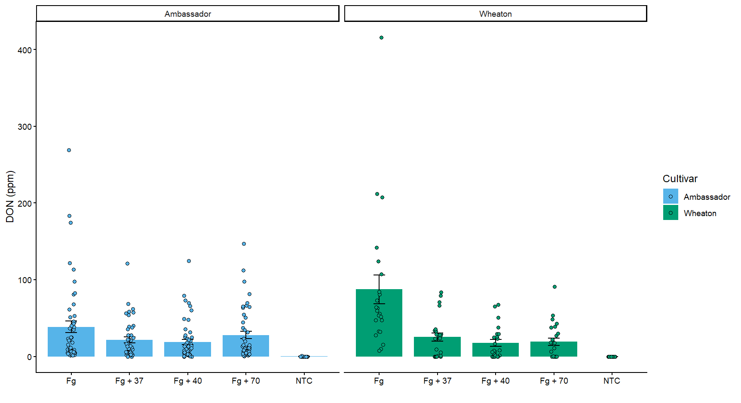

3 pts. Add transparency to the points so you can still see the boxplot or bar in the background.

